1. **Windows**[**​**](https://docs.rancherdesktop.io/getting-started/installation/#windows)

**Requirements**[**​**](https://docs.rancherdesktop.io/getting-started/installation/#requirements-1)

Rancher Desktop requires the following on Windows:

* One of
  + Windows 10 with latest updates. The Home edition is supported.
  + Windows 11 with latest updates. The Home edition is supported.
  + Windows 2022 Server with latest updates.
* Running on a machine with [virtualization capabilities](https://docs.microsoft.com/en-us/windows/wsl/troubleshooting#error-0x80370102-the-virtual-machine-could-not-be-started-because-a-required-feature-is-not-installed).
* Persistent internet connection.

Rancher Desktop requires [Windows Subsystem for Linux](https://docs.microsoft.com/en-us/windows/wsl/install-win10) on Windows; this will automatically be installed as part of the Rancher Desktop setup. Manually downloading a distribution is not necessary.

It is also recommended to have:

* 8 GB of memory
* 4 CPU

Additional resources may be required depending on the workloads you plan to run.

**Note:** You can use Rancher Desktop as a Non-Admin user on a Windows machine. However, an Admin's intervention is required during the installation process for the below components.

* **WSL2 - ** You need Admin privileges to install WSL2, which is an essential component of Rancher Desktop.
* **Rancher Desktop Privileged Service - ** You need Admin privileges to install the Rancher Desktop privileged service, which is required to expose applications/services, running inside containers, on all interfaces on the host machine. However, you can skip the installation of the Rancher Desktop Privileged Service with the limitation that you will not be able to expose applications/services on any interface except 127.0.0.1.

**Installing Rancher Desktop on Windows**[**​**](https://docs.rancherdesktop.io/getting-started/installation/#installing-rancher-desktop-on-windows)

1. Go to the [releases page](https://github.com/rancher-sandbox/rancher-desktop/releases) on GitHub.
2. Find the version of Rancher Desktop you want to download.
3. Expand the **Assets** section and download the Windows installer. It will be called Rancher.Desktop.Setup.X.Y.Z.msi, where X.Y.Z is the version of Rancher Desktop.
4. Navigate to the directory where you downloaded the installer to and run the installer. This will usually be the Downloads folder.
5. Review the License Agreement and click **I Agree** to proceed with the installation.
6. If prompted, choose between installing for everyone on the machine or installing just for the current user. Installing for everyone is preferred in order to install the Rancher Desktop Privileged Service, as noted above.
7. Follow the prompts to confirm installation.
8. When the installation completes, click **Finish** to close the installation wizard.

**Uninstalling Rancher Desktop on Windows**[**​**](https://docs.rancherdesktop.io/getting-started/installation/#uninstalling-rancher-desktop-on-windows)

1. From the taskbar, click the **Start** menu.
2. Go to **Settings > Apps > Apps & features**.
3. Find and select the Rancher Desktop entry.
4. Click **Uninstall** and click it again when the confirmation appears.
5. Follow the prompts on the Rancher Desktop uninstaller to proceed.
6. Click **Finish** when complete.
7. Now lets install WSL2 version

First check the widows version click the windows + r button and type winver

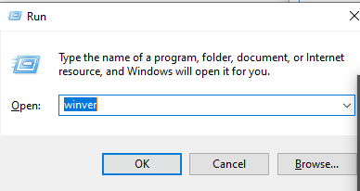

Click ok

**Step 1 - Enable the Windows Subsystem for Linux - Open powershell and run below command**

dism.exe /online /enable-feature /featurename:Microsoft-Windows-Subsystem-Linux /all /norestart

**Step 2 Enable Virtual machine feature**

dism.exe /online /enable-feature /featurename:VirtualMachinePlatform /all /norestart

**step 3 Download the linux kernel update package click and run it**

<https://wslstorestorage.blob.core.windows.net/wslblob/wsl_update_x64.msi>

**Step 4 - Set WSL 2 as your default version**

wsl --set-default-version 2

**Step 6 - Install your Linux distribution of choice**

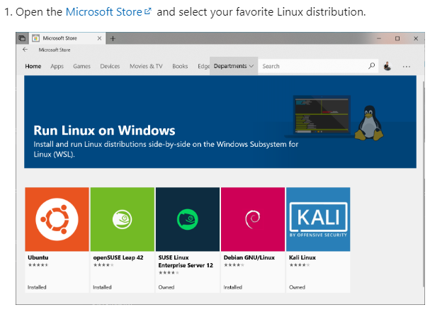

Now, if you want you can install this, but in the Rancher Requirements it says it will automatically be installed as part of the Rancher setup. Manually downloading a distribution is not necessary.

**Rancher Download and Installation**

1. Go to <https://rancherdesktop.io/>
2. Select your operating system
3. Double click to install
4. Click next….
5. Once installed
6. It will install k3s – Kubernetes
7. Click preferences – wsl 🡪 As Rancher said in the documentation that it will install the linux dist. But If you don’t see, then install manually.
8. Open browser -- go to Microsoft store
9. Ubuntu 20.04 -- download and install
10. First time username and password will create your user. **Make sure to write it down somewhere.**
11. Close the linux and also close the rancher desktop completely. Re-start rancher desktop
12. Now check wsl – you should see ubuntu automaticall selected  
    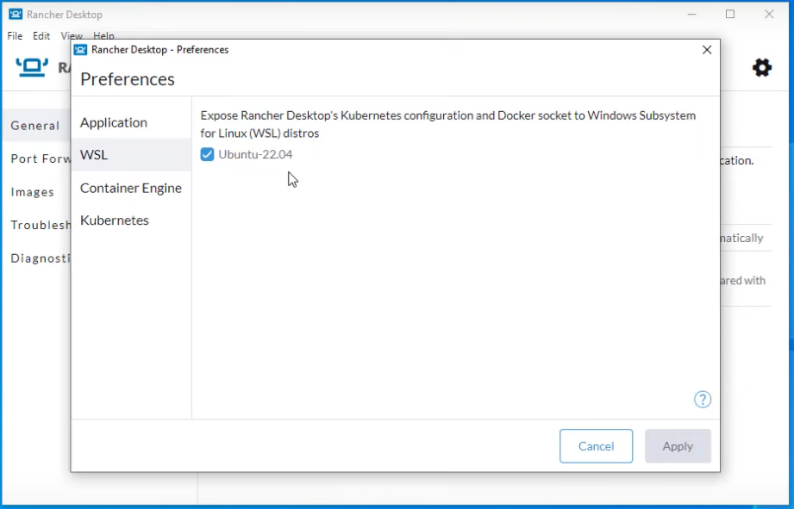
13. Now click on the container engine – containerd
14. Now open powershell as administrator –> wsl -l -v
15. You should see this  
    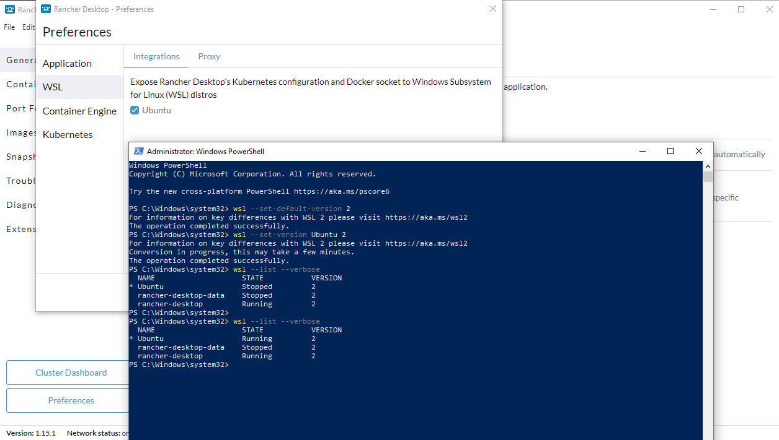
16. Here version is the version of wsl – wsl2
17. Now open ubuntu
18. Type nerdctl images – you should see this  
    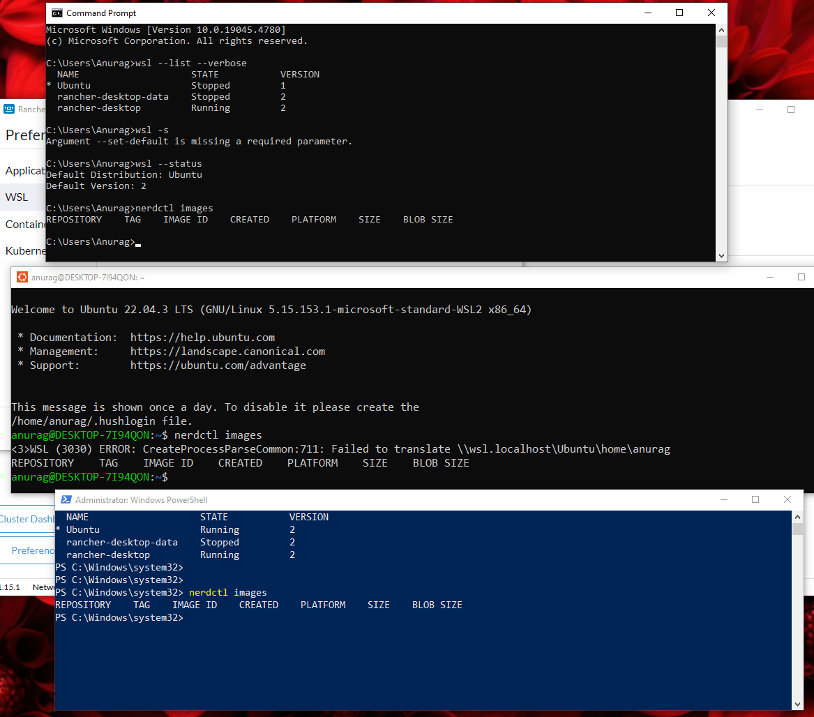
19. Type kubectl get nodes to check whether kubectl is working or not.  
    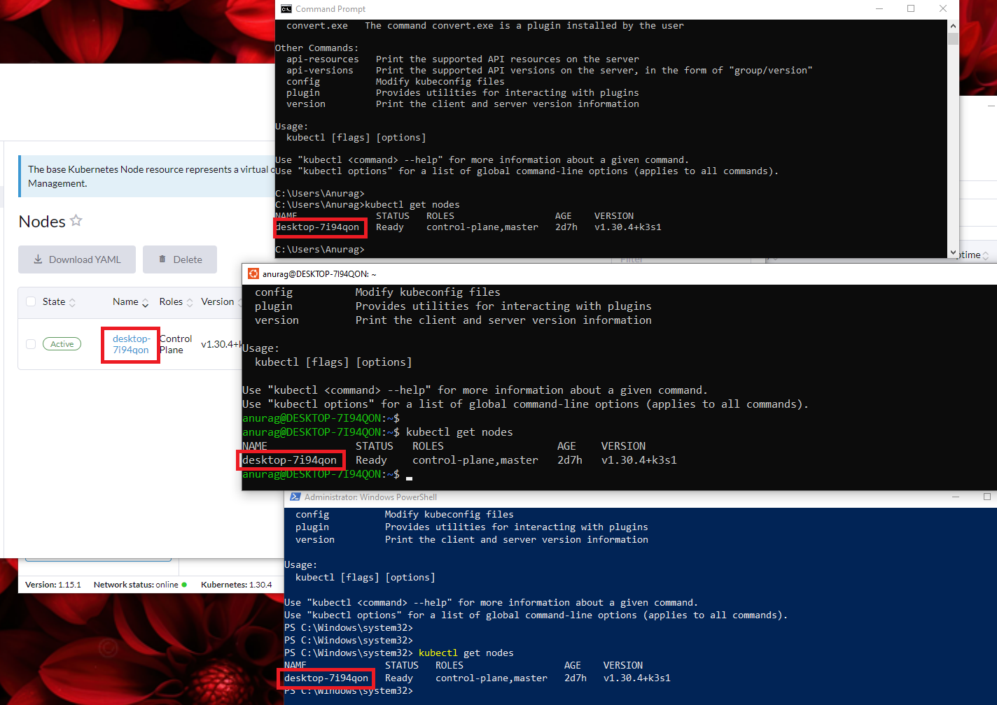
20. Kubectl get pods -A 🡪 this will show you all the pods running inside the node
21. 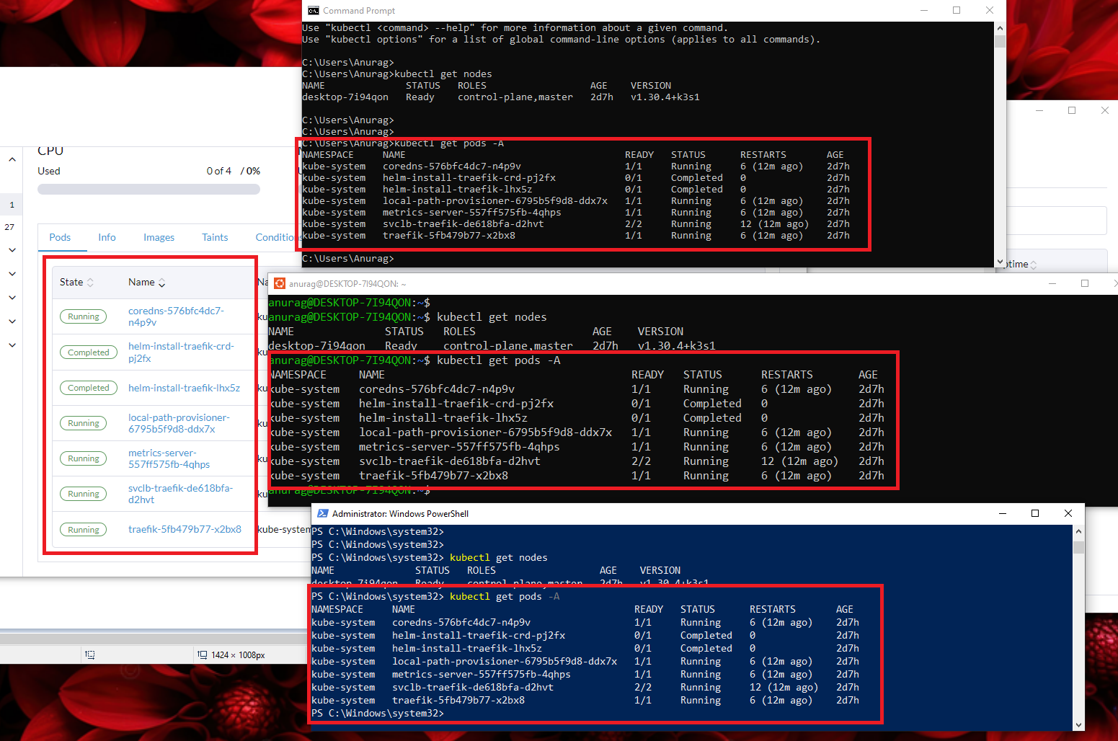
22. To create a namespace  
    nerdctl namespace create <namespaceName>  
    nerdctl namespace ls
23. Now lets build an image inside the namespace  
    nerdctl -n <namespaceName> build –tag <imageName>:version
24. To check the image created  
    nerdctl -n <namespaceName> images
25. Go to rancher preferences 🡪 images 🡪 select namespace 🡪 addImage  
    write the public image name example brainstorm/multicontainer:stable  
    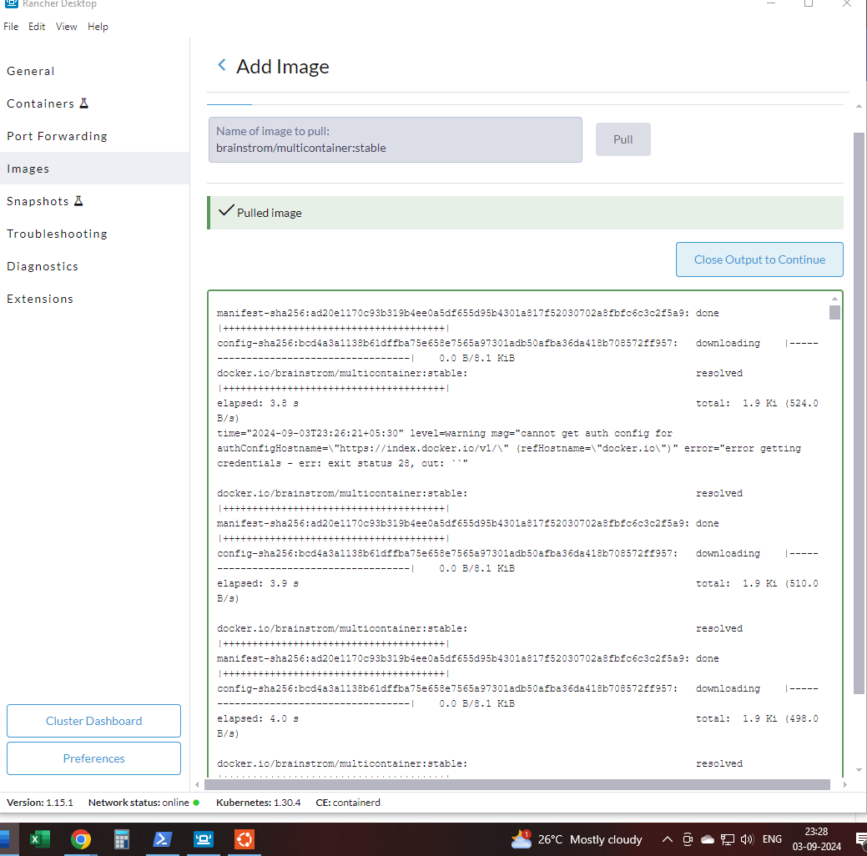
26. Click images tab and the check the image downloaded  
    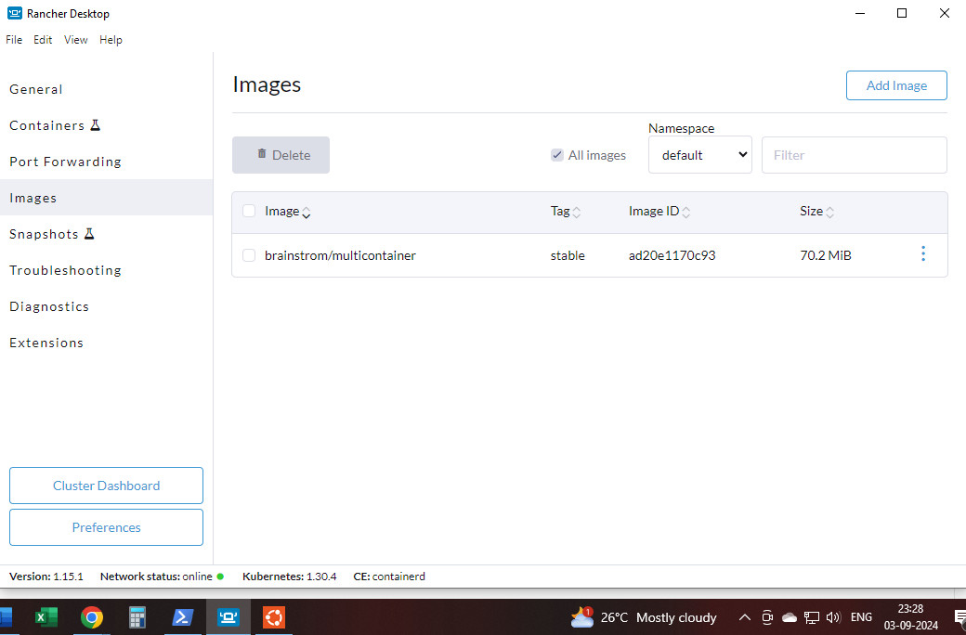
27. Now create a namespace, or use the one created before
28. Then pull an image 🡪 nginx:latest  
    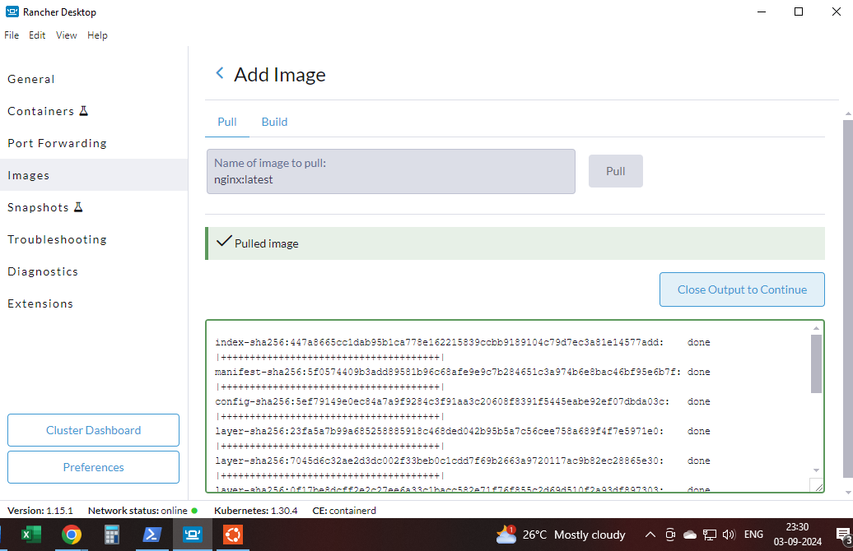
29. Scan the image  
    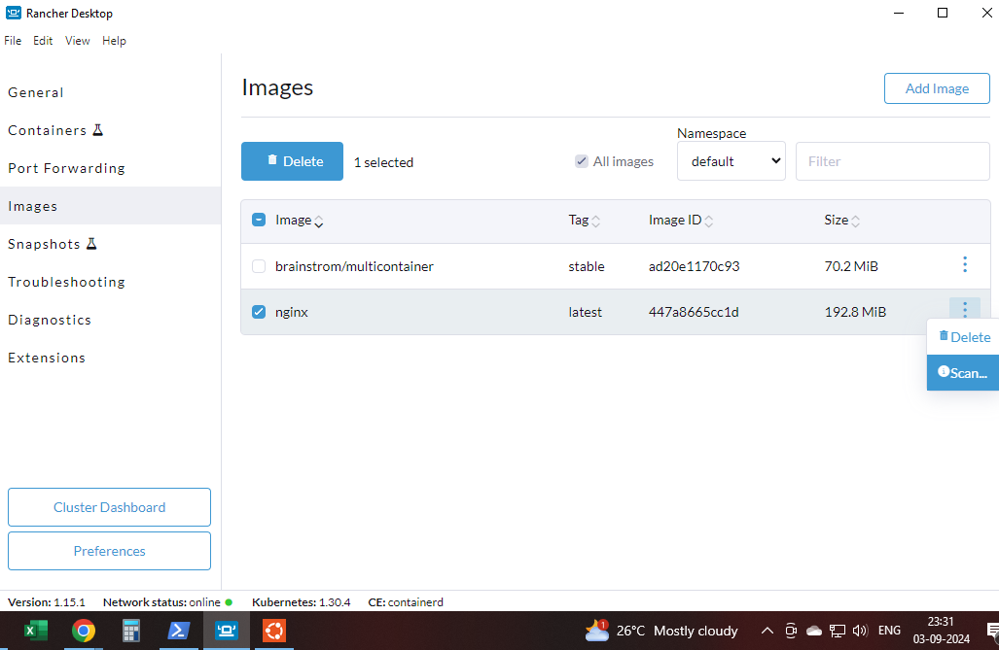
30. Now type this and start the container of inginx  
    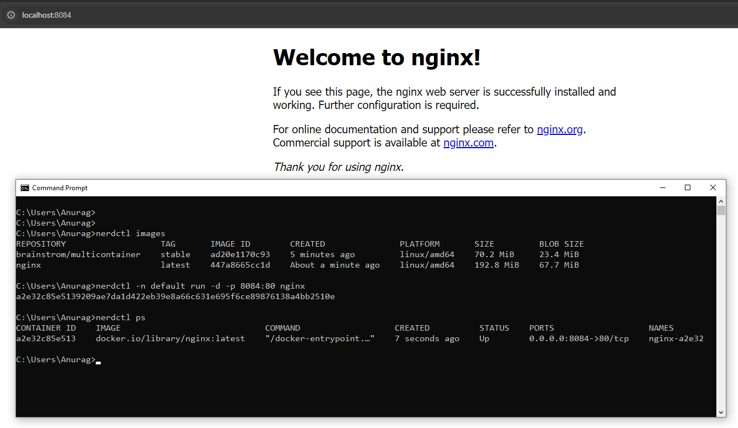
31. Now lets create a Kubernetes resource pods  
    kubectl run nginx-server –image=nginx –port 80  
    kubectl get pods  
    kubectl port-forward pods/nginx-server 8085:80  
    